

BAJAJ AUTO LTD FINANCIAL ANALYSIS

**Bajaj Auto Financial Analysis (2014-2024)**

Bajaj Auto Limited, one of India's leading manufacturers of two-wheelers and three-wheelers, has consistently been a significant player in the global automobile sector. Analyzing its financial performance over the last 10 year through matrix analysis provides a comprehensive view of the company's operational efficiency, profitability, and strategic positioning.

* **Sales growth** - Refers to the increase in a company's sales over a specific period, typically expressed as a percentage. It is an important metric that shows how well a business is expanding and attracting more customers or increasing the value of sales per customer.
* **Profit Margin** - This ratio shows what percentage of revenue is profit after all expenses.
* **Depreciation** **-**The company reported a decrease in sales due to the depreciation of their products' value over time."
* **Interest** - It shows how easily a company can pay interest on its debt.
* **Operating expense -** financial metric that shows the proportion of a company's operating expenses relative to its sales revenue.

**To Analysis the financial status of BAJAJ AUTO LTD we can use Financial Matrices.**

**Financial metrics:**

1. **Sales Growth**
2. **Profit Margin**
3. **Depreciation/ Sales**
4. **Interest Expense/ Sales**
5. **Operating Expense/ Sales**
6. **Sales Growth (%)**

Sales growth is market a key indicator of a company's performance and its ability to attract customers over time. Bajaj Auto has shown fluctuating sales trends over the past decade, shaped by internal strategies, market conditions, and global economic factors. Here’s 10 year of the sales growth in positive of the Bajaj Auto.

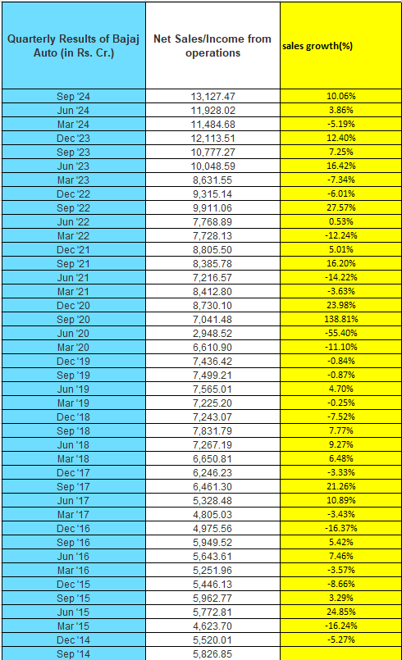

**Sales growth(%)**

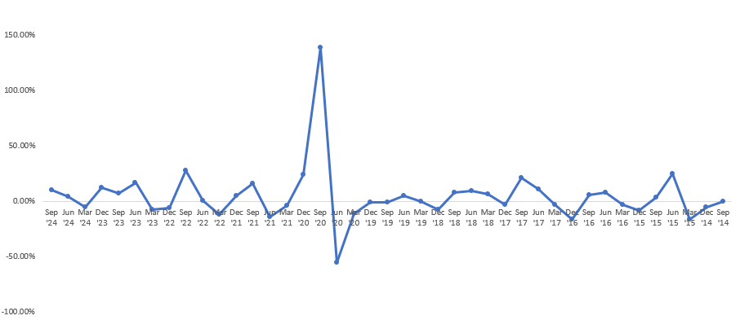

**Analysis/Finding:**

**1. Strong Performance :** Bajaj auto company after the covid completed and then strong growth of 130% above, supported by increased demand and improved sales figures over Jun'20.

**2. High Variability :** The sales growth percentage fluctuates widely, with notable peaks and dips, indicating inconsistent sales growth over the observed period.

**3. Negative and Positive Phases :** The graph shows periods of both positive and negative growth, with some instances of prolonged negative trends, suggesting occasional challenges in maintaining growth.

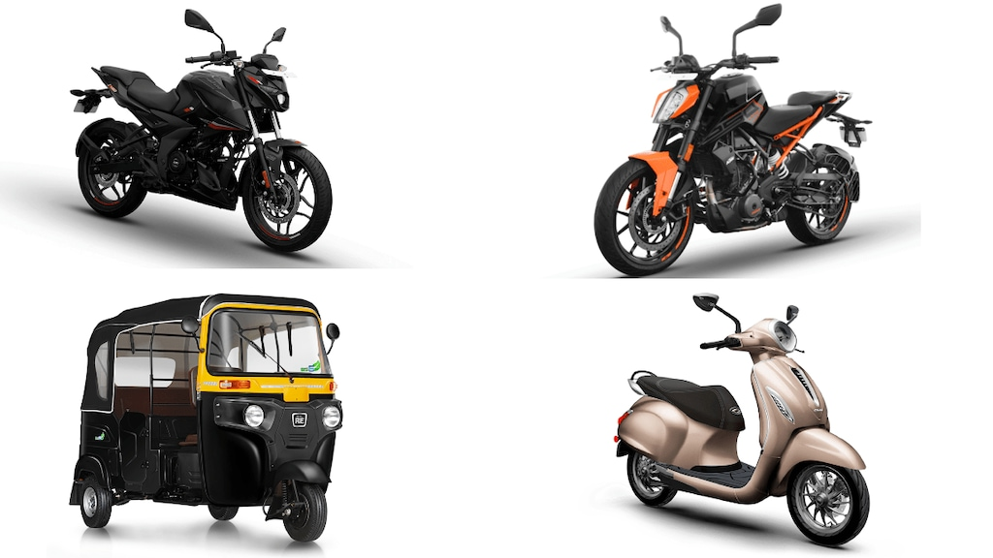

1. **Profit Margin (%)**

Bajaj Auto's quarterly profit margins, net profits, and revenue (sales/income from operations) from September 2014 to September 2024 in this duration covid had comes and also Bajaj Auto has demonstrated consistent financial health, balancing growth and profitability. The company's strategic focus on high-margin exports and diversified product portfolios has helped it weather market challenges and economic downturns.

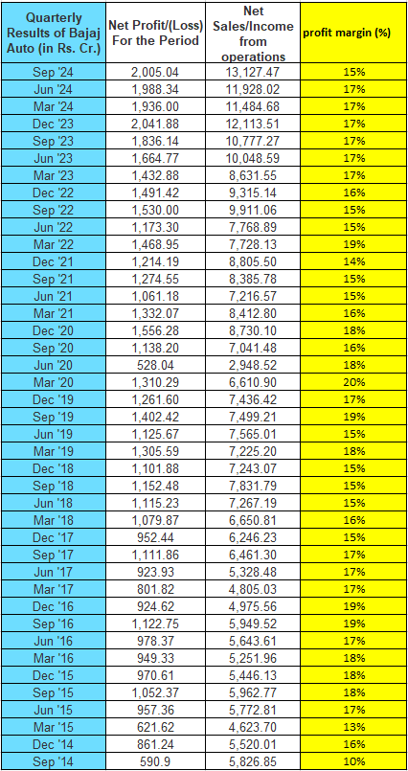

**Profit Margin(%)**

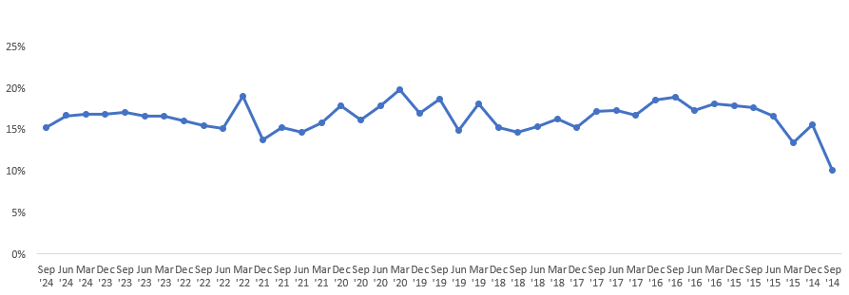

**Analysis/Finding:**

1. **Consistent Performance :** The company has maintained steady profit margins and sales growth, showcasing strong operational efficiency and market position.
2. **Long-Term Growth :** From Sep '14 (₹5,826.85 crore) to Sep '24 (₹13,127.47 crore), net sales have increased significantly, highlighting long-term expansion.
3. **Challenges :** Profit margin in recent quarters has slightly declined, indicating possible cost pressures or increased competition.

**3.0 Deprecation /sales**

The depreciation-to-sales ratio reflects strong financial health and operational efficiency for Bajaj Auto. However, the company should balance its focus on asset utilization with periodic reinvestments to sustain long-term competitiveness.

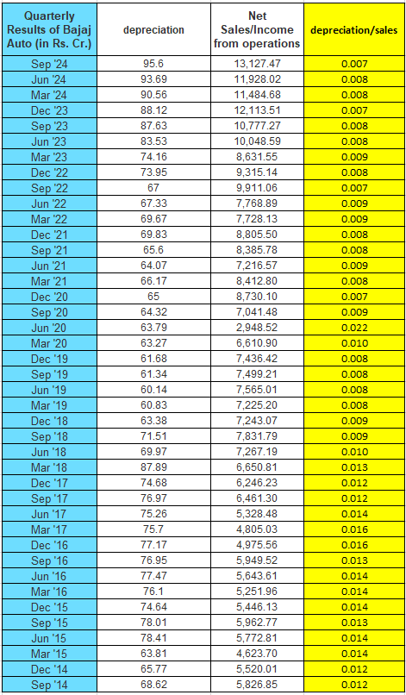

**Deprecation /sales**

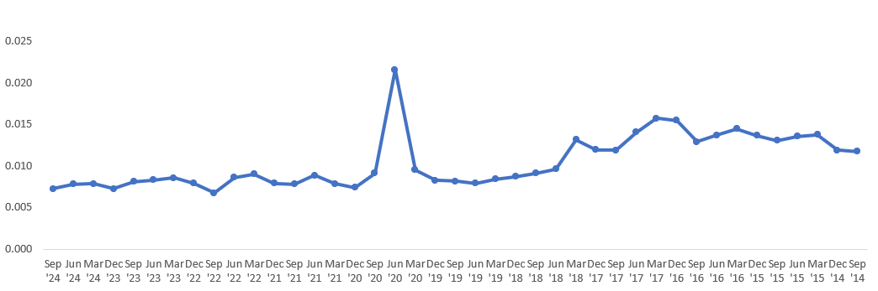

**Analysis/Finding:**

**1**.**Efficiency Improvements :** The lower depreciation-to-sales ratio in recent periods indicates better management of fixed assets. It could be due to:

* Investments in long-lasting equipment.
* Lower reliance on capital-intensive assets.
* Improved production methods or asset efficiency.

**2.** **Industry Benchmark :** A low and stable depreciation-to-sales ratio is a sign of strong financial health. Bajaj Auto appears to be maintaining this, even during challenging periods.

**3.** **Asset Turnover :** The consistent depreciation levels paired with rising revenues indicate that the company's capital investments are being effectively utilized to generate more sales

1. **Interest/sales**

The interest-to-sales ratio shows how much of a company's revenue is used to pay interest on its debts. A lower ratio is generally better, as it means the company is spending less on interest and more on growing its business.

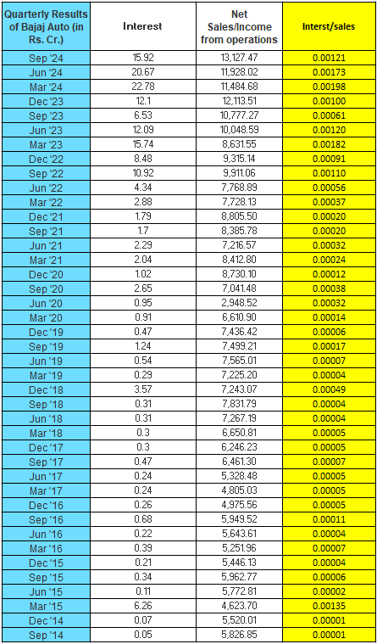

**Interest/sales**

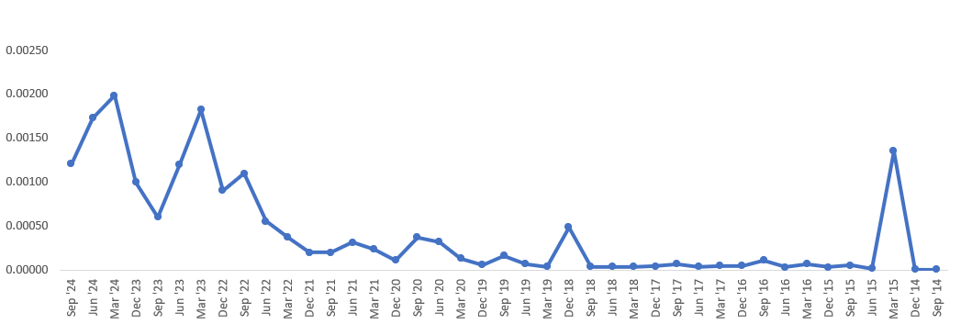

**Analysis/Finding:**

1. **Overall Trend :** The graph shows a general upward trend over time, but the company was spending more cash on machinery like equipment or buildings (for the depreciation).
2. **Interest Increase (dec'20 - mar'24) :** The company's loan for a new machine raised interest costs, but efficient steps to reduce this show positive progress.
3. **Interest less (Jun'15-Sep'18) :**  Less Interest pay on debts in this duration.
4. **Operating expense/sales**

This ratio shows how much of the sales revenue goes toward covering operating expenses, like salaries, rent, and utilities. A lower ratio indicates better efficiency, meaning the company is generating more sales for every rupee spent on operations. The continuous decline in recent years reflects strong cost discipline and revenue growth, contributing to profitability.

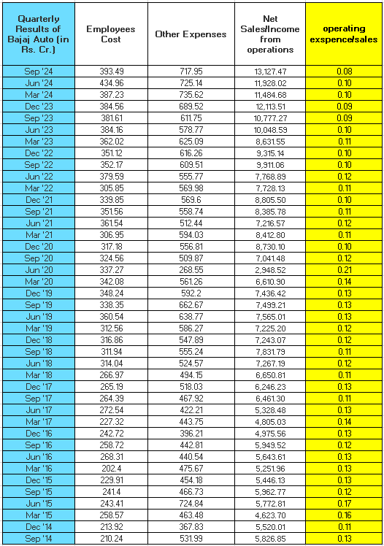

**Operating expense/sales**

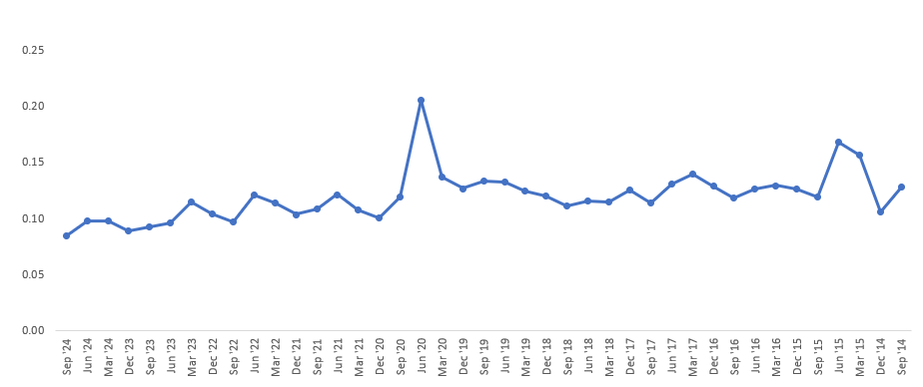

**Analysis/Finding:**

1. **Operating expense trend :** The graph shows a general decrease in operational cost as a percentage of sales over time.
2. **Recent Strength in Cost Controls :** Improved process efficiency and technology adoption. Better cost containment strategies amidst rising revenues.

**Conclusion:**

This analysis will serve as a foundation for understanding Bajaj Auto's financial resilience and adaptability. Insights from the matrix will be valuable for stakeholders, including investors, policymakers, and management, in shaping future strategies.

Presented By :

Yuvaraj Shivamurti

BAJAJ AUTO FINANCIL DATA LAST (2014-2024) 10 YEAR WEBSITE:

<https://1drv.ms/x/c/56b5dc68913e2033/EZvsdA83gIhMtgpMMA2SNJMBYrUnsjyKp2uY06Hq7Nw95A?e=DYwt6u>

LinkedIn website:

<https://www.linkedin.com/in/yuvaraj-shivamurti-13929228b?lipi=urn%3Ali%3Apage%3Ad_flagship3_profile_view_base_contact_details%3B5AmZ0FEZRLedpoaOwux5xA%3D%3D>